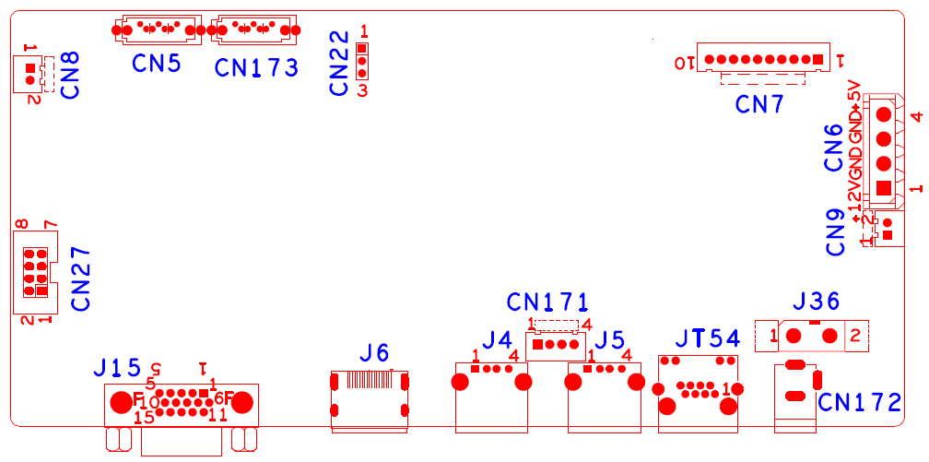

 | Functional description | Interface Definitioin
CN27 | Alarm Input and Output expansion pedestal | 1:Input | 2:Output | 3:NC | 4:NC
 |  | 5:GND | 6:NC | 7:+5V | GND
CN8 | Fun Power | 1:+12V | 2:GND
CN5 | SATA interface
CN173 | SATA interface
CN22 | RS232 Serial port
CN7 | 10PIN Without SCM front panel pedestal | 1:+3.3 | 2:GND | 3:IR | 4:COL2
 |  | 5:COL1 | 6:ROW2 | 7:COL3 | 8:ROW1
 |  | 9:ALARM | 10:REC
CN6 | Hard drive power pedestal | 1:+12V | 2:GND | 3:GND | 4:+5V
CN9 | Fan power pedestal | 1:+12V | 2:GND
J36 | 12V power input switch
CN172 | 12V Power input interface
JT54 | Network Interface
J5 | USB Interface | 1:+5V | 2:D- | 3:D+ | 4:GND
J4 | USB Interface | 1:+5V | 2:D- | 3:D+ | 4:GND
CN171 | USB expansion pedestal | 1:+5V | 2:USB1DM-FRONT | 3:USB1DP-FRONT | 4:GND
J6 | HDMI interface
J15 | VGA interface

